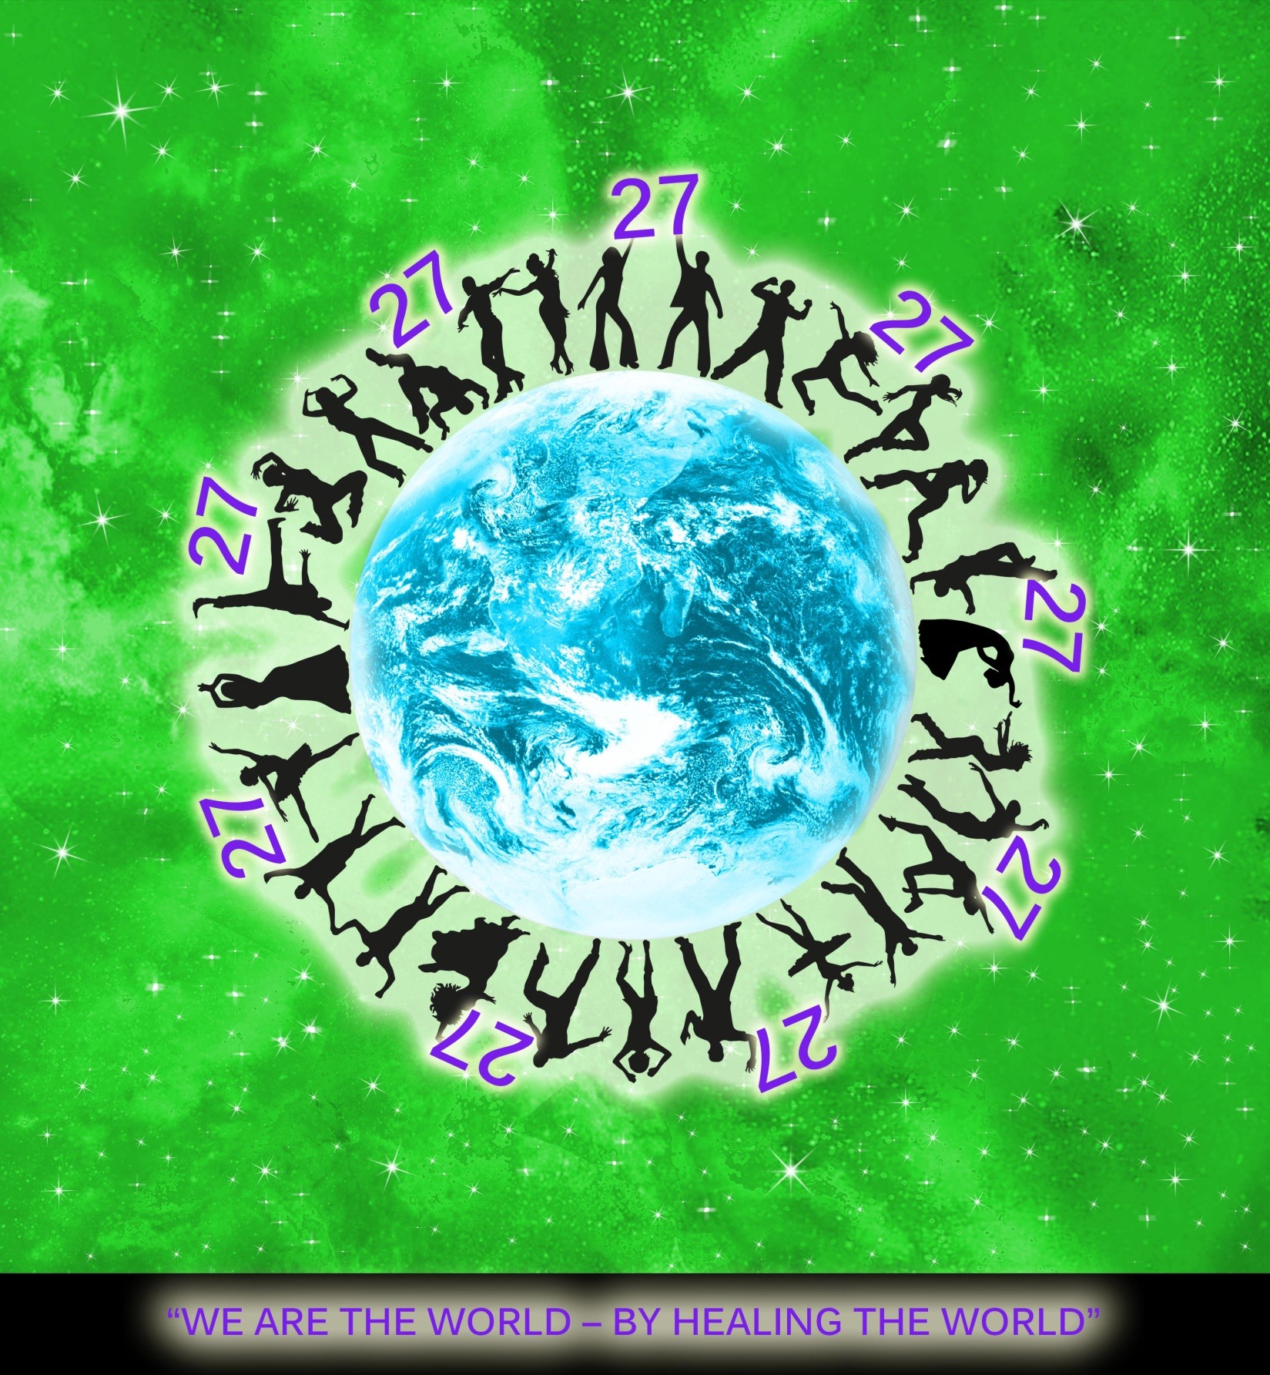

The Code

Club 27 “We are the world – BY HEALING THE WORLD”

THE INTERNATIONAL ASSOCIATION

THE CODE
CLUB 27 “We are the world -
- by healing the world”

The establishment
The International Association Club 27 (further as “the Association” or “Club 27”) has been established in the Slovak Republic in 2017 by the following members:
- Kamila Dolná
- Theodoros Kalathakis
- Nicole Kottnauerová
- Eliška Jaďuďová

The Aim and MAIN SCOPE
The main aim of the Association is to help all good international talents, ideas, businesses, visions and plans to see the light and have a chance to achieve success.
The main intention and approach towards this aim is to have no boundaries, no borders, no nationalities, no religions, no nationalism, no egoism, no politics, no comparisons, no patriotism, and no limits at all. We are the world.

The slogan
“We Are the World – By Healing the World” is the main slogan and the main motto of the Association. There is no difference between people, each and every one of them is individual and unique, and at the same time each one is not better or worse than the other. And any creative, unique and progressive ideas can see the light and become true thanks to Club 27 and with the help of its members.

PURPOSE
Club 27 supports a person's individualism (not egoism) and creativity when it is reinforced by a talent of any kind and comes from the inner source of each individual.
The world has been divided into parts, not by nature, but by the human mind. And therefore there are no limitations for the members to overcome borders and become truly global. Club 27 supports only those projects that are not national, resp. are either not within the country of origin or the partners in such project are of different nationality; therefore, the platform is international.
All the members, regardless of their religious, national or political identity declare that within the activities of Club 27 and among all the members, the political, religious, national or any other status will be never taken into consideration; all members are absolutely equal and any issues of identity and ego will be left “behind the doors”.
All members of Club 27 support the “no mind” status, inner worth of each individual person; they support meditation and living life in the present moment.
The main scope is to support any meaningful projects created or invented by people with enthusiasm, creativity and willingness. Club 27 supports visions which are international or suitable to truly go beyond borders such as the nationality of the project partners.
This international platform helps to connect ideas, talents and sources with support from the Members in various forms such as:
- Help with administration, marketing, promotion, legislation, consultancy, legal consultancy, connecting people, contacts, help with the foundation of the companies, personnel issues, placement of the potential business… etc., up to financial support and much more.
- Offering a name, trademark, reputation, recognition, image…

The reward for the Full Member:
While establishing a new legal business entity, regardless how big the support (material or non-material) by a Full Member is, the Full Member is allowed to hold maximum 27% of the a new established business entity.

MEMBERSHIP

categories of membership:
- MEMBER
- AWARDED MEMBER
- ERI MEMBER
1. Member
- can register at any time or by paying a Registration fee yearly
- has a full access to the database, projects, contacts and all information published on the Club 27 websites; in order to find a partner for ideas in international scale of business

2. awarded Member
- is a person or a legal body who is awarded by Board of Directors for a Member without Registration fe instalments
- has a full access to the database, projects, contacts and all information published on the Club 27 websites
3. ERI Member
- becomes automatic member by purchasing ERI device, receives a Code to Enter paid ON Line Seminars /only for members/
- has a full access to the database, projects, contacts and all information published on the Club 27 websites;

How to become a member:
- To pay a full registration fee;
- to Purchase ERI
- to be awarded

Registration fee:
- Member: 200 EUR and i case of realising a Project through Club 27 up to 27 % of the First year Profit or Life time Profit from the Arranged Business activity
- ERI Member: By Purchasing ERI device
In case of realising a new project, the intermediate fee is payable when the Project gets functioned.
Whether the project has been successfully fulfilled is decided based on the evaluation. This evaluation:
- happens after a certain period (the length of such period is settled by the Statutes);
- Is a subjective evaluation by each and every project partner that the project has fulfilled/reached its purpose, goal, usefulness or/and financial aim.

MISSION
The funds earned/gained by the Association or its members will be used to ensure smooth running of Club 27, and especially to support the mission of Club 27: “We Are the World – By Healing the World”:
- To destroy the boarders and reunite the World;
- To support human rights which are created by nature, not by human mind (means they are non-political, non-religious, non-rational, without influence of education clichés…etc.)
- To support finding the natural inner potential of every person; potential that can be rediscovered through a healing path only. Club 27 will support any natural healing of people:
  - meditation
  - body-mind healing
  - alternative forms of medicine (with main focus on ERI-CME diagnostics and prevention)

The Association's funds/earnings will be used not only to promote a helpful alternative medicine and meditation forms and centers, but also to appeal on Governmental decisions in specific countries to include Alternative medicine and Meditation as fully recognized forms of health services!

