DIRECTIVE OF CLUB 27 no. 1/2019 on Use of Symbols

The CLUB 27 presidency agreed on the following Directive:

§ 1
SYMBOLS

- Symbols of civil society organization CLUB 27 – international association (hereinafter as “CLUB 27”) include the CLUB 27 logo and the CLUB 27 seal.
- The CLUB 27 logo represents a globe with a blue, white and golden color image of the earth's surface lined with twenty-seven moving figures in black and gold image displayed in a white square with the CLUB 27 word mark in black and gold image.
- The CLUB 27 seal is formed of one-color CLUB 27 logo or embossed CLUB 27 logo (dry seal).
- Image of the CLUB 27 logo is included in the annex of this Directive.
- Technical parameters of image of the CLUB 27 logo are published on the CLUB 27 website.
§ 2
USE OF SYMBOLS

- The CLUB 27 symbols may be used only in the way established by this Directive or other CLUB 27 rules.
- Any other use (modified or distorted) of the CLUB 27 logo is prohibited.
- A CLUB 27 member and a person who was granted a license by contract (so-called associated member) may always use the CLUB 27 logo only in such way that its use is dignified and does not dishonor the CLUB 27.
- The CLUB 27 members and persons who were granted a license by contract (so-called associated member), may use the CLUB 27 logo particularly:
(a) on the website of the CLUB 27 members,
(b) in advertising and other promotional materials,
(c) on business cards or documents,
(d) in contractual documents,
(e) in e-mail communication,
(f) in the workplace of the CLUB 27 member or person who was granted a license by contract (so-called associated member), including entrance door.
- The symbols are owned by the CLUB 27 and all rights to them are managed solely by the CLUB 27. The right to use the CLUB 27 logo may be transferred to another person with the consent of the CLUB 27 chairman.
- Only the CLUB 27 members and persons who were granted a license by contract (so-called associated member) have the right to use the CLUB 27 logo.
- Only the member of the CLUB 27 presidency has the right to use the CLUB 27 seal.
- The CLUB 27 logo is displayed in color. Exceptionally, if it is not possible or appropriate for objective reasons, the color image may be waived.
- In case that the membership in the CLUB 27 is terminated, the CLUB 27 member loses also the right to use the CLUB 27 logo. The person who stopped being the CLUB 27 member is obligated, within 30 days from the date of termination, to remove the CLUB 27 logo from all elements where it was used.
§ 3
FINAL PROVISIONS
This Directive is effective from June 1, 2019.

Annex

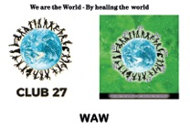
IMAGE OF CLUB 27 LOGO
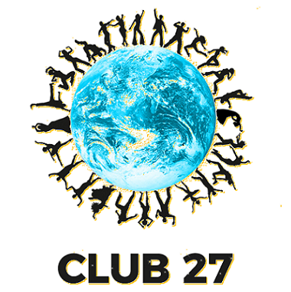

ANNEX 2

The agreed AREA or FIELD of Using the Symbols:

