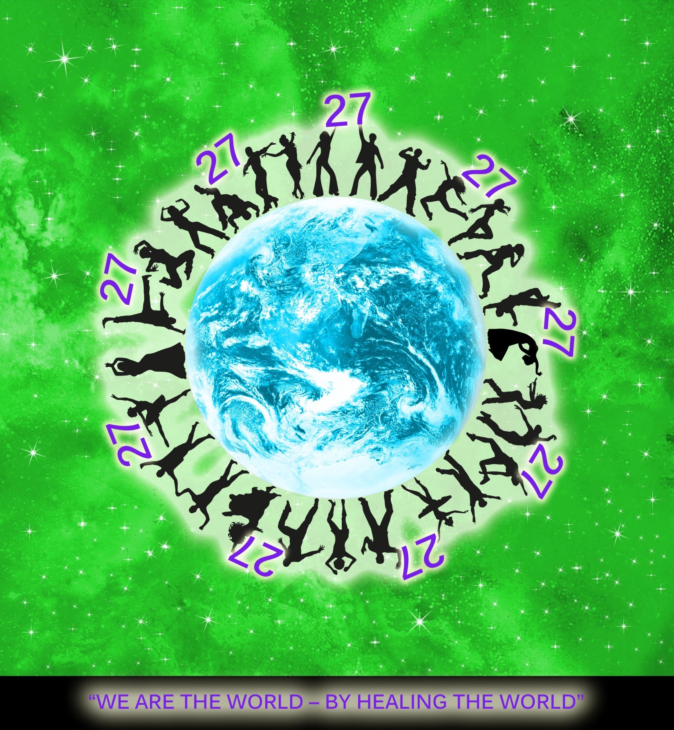

The golden Code “27”
Club 27 “We are the world – BY HEALING THE WORLD”
THE GOLDEN CODE “27”
- Each human must have right and potential to keep his health status under chosen conditions.

2. Each human is so/also obliged to bear a responsibility for the chosen health status and should not create over necessary burden to the society.

3. Each human can choose the way of prevention and the way of keeping balanced health. All possible ways must be available and equally supported by all Health care systems.

4. Each human has right for liberty as presented in the international declaration of human rights. No government can restrict this liberty even in the matter of how to protect each human health status.

5. There must be available platform how to get prepared each human to be able to live consciously and bear responsibility for his own health status. This involves effective and fast diagnostics methods.

- the process of preparation should start during Education in childhood, including the Meditations
- A new forms of diagnostics and prevention could be used to help each individual's work on balancing the health status, as far as Diagnostics represents 90% of the success. Only 10% is Medicine. Proper Diagnostics can limit fears and inefficient ways of healing.

6. The advanced new forms of diagnostics, healing and prevention can also improve safety against pollution and bring existential connection/explanation between science and religion.

How to become a golden member:
- Just support the GOLDEN CODE “27” and help to change the way of life of this planet

